26.33: A half-scale reading occurs with 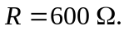 So the current through the galvanometer is half the full-scale current.
